

**National University of Sciences & Technology**

**School of Electrical Engineering & Computer Science**

**CS250 – Introduction to Entrepreneurship**

Submission Details

|  |  |
| --- | --- |
| Names | CMS ID |
| Danial Ahmad | 331388 |
| Muhammad Ahmed Mohsin | 333060 |
| Muhammad Ali Farooq | 331879 |
| Muhammad Umer | 345834 |
| Syeda Fatima Zahra | 334379 |
| Faculty Member | Dr. Zunaira Saqib |
| Class | BEE 12-C |
| Date | 26/04/2024 |

**Table of Contents**

2 Idea: GradCompass 2

2.1 The Problem 2

2.2 The Solution 2

2.3 Industry Insights 3

2.4 Unique Selling Proposition (USP) 3

2.5 Cost Leadership or Differentiation 4

2.6 Target Market and Customer Personas 4

2.6.1 Customer Persona – 1 4

2.6.2 Customer Persona – 2 5

3 Idea: Rent-X 6

3.1 The Problem 6

3.2 The Solution 6

3.3 Industry Insights 7

3.4 Unique Selling Proposition (USP) 8

3.5 Cost Leadership or Differentiation 8

3.6 Target Market and Customer Personas 8

3.6.1 Customer Persona – 1 (Consumer) 9

3.6.2 Customer Persona – 2 (Renter) 9

4 Idea: Sahara 10

4.1 Problem: 10

4.2 The Solution 10

4.3 Industry Insights 10

4.4 Unique Selling Proposition (USP) 11

4.5 Cost Leadership or Differentiation 12

4.6 Target Market and Customer Personas 12

4.6.1 Customer Persona – 1 13

4.6.2 Customer Persona – 2 13

# Idea: GradCompass

## The Problem

International students, especially from regions like Pakistan, struggle with the complexities of graduate school applications due to a lack of information, research focus mismatch, confusing application processes, and limited access to mentorship. This leads to missed opportunities, stress, and lower acceptance rates. Thus, the 4 W’s are:

* **Who:** Primarily affects students in Pakistan aspiring to pursue graduate studies abroad, especially in research-oriented fields.
* **What:** Leads to missed opportunities, mismatched program selections, lower acceptance rates, and increased stress and anxiety for applicants.
* **Where:** Problem exists globally but is particularly pronounced in regions with limited access to educational consulting and mentorship resources, such as Pakistan.
* **When:** Arises throughout the entire graduate school application journey, from initial research and program selection to application submission and interview preparation.

## The Solution

GradCompass addresses these challenges by offering a comprehensive platform with both free and premium services:

* **AI-Powered University Comparison:** The core offering is a Generative Artificial Intelligence (GenAI) model that generates detailed comparison documents for universities and programs based on user input (desired country, program, and specific field). This document would include:
  + *Program Details:* Curriculum, course offerings, research focus, and faculty expertise.
  + *Professor Profiles:* Research interests, publications, and contact information.
  + *Stipend and Funding Information:* Details on available scholarships, financial aid, etc.
* **Monetization Strategy (how we plan to make money!)**
  + *Free Tier:* Provides limited access to the AI comparison tool (just for showcasing), allowing users to compare a few universities and programs. This tier also includes access to basic resources like SOP samples, blog posts, and general application tips.
  + *Premium Tier (~21-day package):*
    - **Unlimited AI Comparison Tool Access** – Unlimited use of the AI comparison tool for generation of comparative documents for multiple universities and programs.
    - **One-on-one Mentorship Services** – Receive personalized guidance from experienced mentors on various aspects of the application process, including essay review, research proposal assistance, interview preparation, and career advice.

*“GradCompass will attract experienced mentors by offering a competitive revenue-sharing model. Mentors will receive a significant percentage of the fees generated from their mentorship sessions, creating a mutually beneficial partnership.”*

## Industry Insights

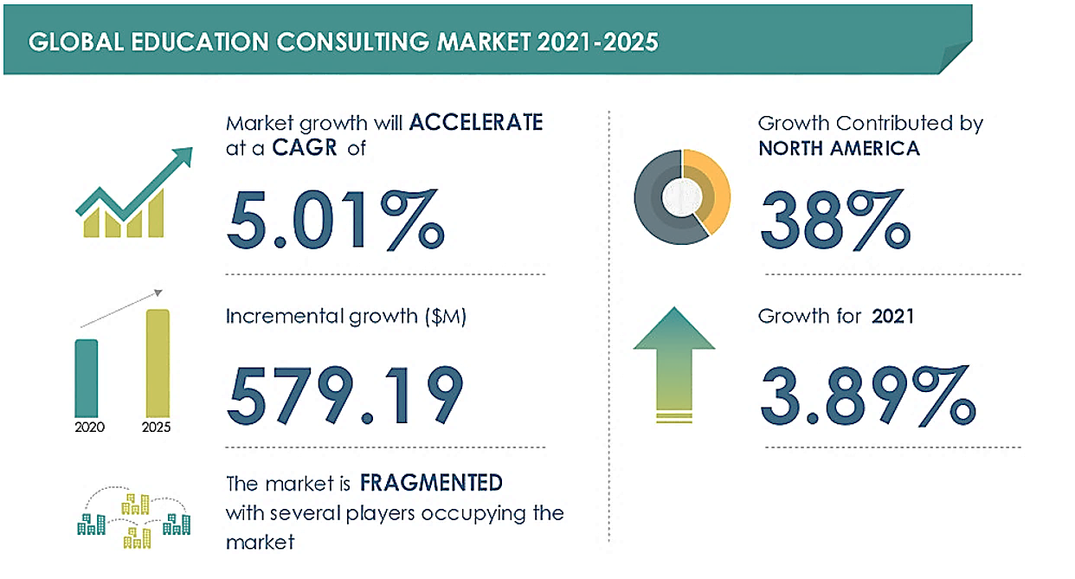

Figure 1 – Latest Education Consulting Market forecast and analysis (2021-2025), Source: Technavio

**Industry:** GradCompass operates within the growing educational consulting market *(Figure 1)*, specifically targeting the graduate school application segment.

* **TAM**

With over 220 million students enrolled in tertiary education globally ([Source: WorldBank](https://www.worldbank.org/en/topic/tertiaryeducation)), and assuming a conservative estimate of 15% pursuing graduate studies, our TAM encompasses approximately 33 million potential graduate students worldwide..

* **SAM**

Focusing on Pakistan, with its annual production of around 445,000 graduates ([Source: HEC](https://www.hec.gov.pk/english/universities/hes/Pages/HEDR-Statistics.aspx)), our SAM is a significant subset of this TAM. We further refine this by targeting graduates proficient in English, ensuring compatibility with our platform and services.

* **SOM**

GradCompass aims to capture a conservative 5% of the SAM within the first two years, translating to serving over 11,000 Pakistani graduates seeking international graduate school opportunities.

## Unique Selling Proposition (USP)

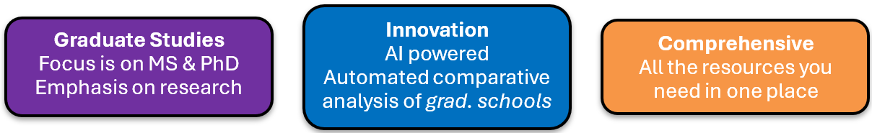

GradCompass's USP lies in its unique combination of AI-powered university comparison, personalized mentorship, and a freemium model catering to a wide range of needs and budgets. This creates a one-stop shop for graduate school applicants, offering unparalleled convenience and value.

## Cost Leadership or Differentiation

GradCompass focuses on **differentiation** through:

* **AI-Powered Technology:** Efficient and convenient university comparison tool providing convenience and saving time and effort.
* **Personalized Mentorship:** Tailored guidance and support from experienced mentors, especially those directly involved in the interested student’s program.
* **Focus on Graduate Education:** While consultancy firms such as *HR Pakistan* and *Kestrel Education* exist, our differentiating factor is through a firm focus on postgraduate education, such as Masters & PhD, which are more often than not fully funded.

## Target Market and Customer Personas

Define your target market by answering:

* **Who is Your Product or Service For?**

GradCompass primarily focuses on Pakistani students aspiring to pursue graduate studies abroad. We cater to those who seek personalized guidance and mentorship to navigate the complexities of international graduate applications.

* **What Needs Does Your Product or Service Meet?**

Our platform addresses the need for comprehensive information on international graduate programs, simplifies the application process, and provides access to expert mentorship, ultimately increasing students' chances of admission success.

* **Who Is Most Likely to Buy Your Product or Service?**

Ambitious students with strong academic backgrounds who recognize the value of personalized guidance and are willing to invest in premium services to achieve their graduate school aspirations.

* **What Demographics are You Targeting?**

We primarily target students aged 22-28, residing in Pakistan, and possessing strong academic credentials from competitive universities.

* **What Psychographics Are You Targeting?**

Our ideal customers are characterized by their ambition, goal-oriented mindset, openness to learning, and comfort with utilizing technology to enhance their educational journey.

### Customer Persona – 1

Meet Ahmed, the determined Pakistani graduate applicant

* **Demographics**
* Age: 24
* Location: Islamabad, Pakistan
* Education: Electrical Engineering, final year student at National University of Science & Technology (NUST)
* **Psychographics**

1. **Goals:** Aspires to pursue a PhD degree in Electrical Engineering at a prestigious university in the USA.
2. **Values:** Highly ambitious and driven. Prioritizes academic excellence and international exposure.
3. **Pain Points:** Limited access to local resources on international graduate programs. Feels a disconnect with the application process for foreign universities. Seeks guidance from mentors who have experience studying abroad.

* **Behaviors**
* Actively researches universities and programs online but struggles to find information specific to Pakistani students.
* Regularly attends career fairs and information sessions at his university.
* Values the opinions of international alumni and professors who can provide insights into foreign graduate programs.
* Seeks scholarships and financial aid opportunities to support his studies abroad.

### Customer Persona – 2

Meet Fatima, the aspiring computer scientist

* **Demographics**
  + Age: 23
  + Location: Lahore, Pakistan
  + Education: Biotechnology, recent graduate from the University of Karachi
* **Psychographics**

1. **Goals:** Aspires to pursue a Masters degree or PhD in Biotechnology or a related field at a renowned university in Europe, known for its cutting-edge research in biotechnology.
2. **Values:** Driven by a desire to make a positive impact on society through scientific advancements.
3. **Pain Points:** Feels uncertain about the specific area of biotechnology to specialize in for her graduate studies. Struggles to find detailed information about research labs and faculty working on her areas of interest at international universities.

* **Behaviors**
  + Actively involved in research projects during her undergraduate studies, potentially with publications or presentations at conferences.
  + Seeks opportunities to gain practical experience through internships or volunteer work in research labs or biotechnology companies.
  + Networks with professors and professionals in the field to gain insights into career paths and opportunities in biotechnology.

# Idea: Rent-X

## The Problem

In today's economy, many individuals possess unused items of value but lack accessible means to monetize them. Current rental platforms in Pakistan inadequately cater to this C2C market, leading to missed opportunities for extra income. Generating passive income for middle-class families is also a big issue in Pakistan, along with the lack of security and trust in such online websites due to no review system available. We can write out the 4 W’s as:

* **Who:** Individuals across various demographics who own underutilized items and those seeking to rent such items.
* **What:** Results in financial losses for owners, limited access to desired items for renters, and an untapped market potential for the sharing economy.
* **Where:** Across Pakistan, particularly in urban areas with higher internet penetration and a growing middle class.
* **When:** Ongoing; exacerbated by economic fluctuations and the increasing desire for flexible access to goods over ownership.

## The Solution

RentX provides a comprehensive and user-friendly peer-to-peer rental platform that addresses these challenges. Specifically, we provide an intuitive interface that allows users to easily list their items for rent or browse available rentals. With streamlined navigation and clear categorization, the platform ensures a smooth experience for both owners and renters, along with a review system for both renters and owners, so that people know who to trust. Following are the key features of RentX:

* **Security and Trust:**
  + *Refundable Deposits:* Protect owners from potential damage and encourage renters to take good care of rented items.
  + *Verified User System:* Implement identity verification measures to reduce the risk of fraudulent activity.
  + *Review System:* Enable users to rate and review each other, building trust and transparency within the community.
* **Convenience Features:**
  + *Optional Delivery Service:* Eliminate the hassle of pick-up and drop-off for bulky or valuable items.
  + *Instructional Videos:* Provide tutorials for complex items to ensure proper usage and minimize damage risks.

**Revenue Model**

Initially, RentX will operate on a commission-free basis, allowing owners to list their items for rent without incurring additional fees. Instead, the platform will generate revenue through targeted advertising and premium listing options. Owners can choose to promote their listings through **paid placements**, ensuring greater visibility and potential for rentals. Future plans include exploring subscription-based models offering benefits such as reduced security deposits for members, further diversifying revenue streams.

## Industry Insights

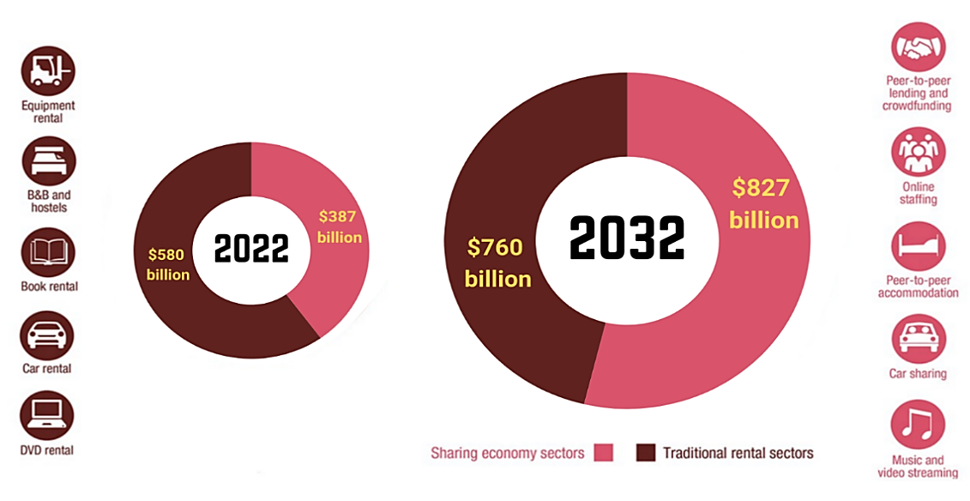

Figure 2 – Source: Global Opportunity Analysis and Industry Forecast, 2023-2032

**Industry:** Sharing Economy (specifically, peer-to-peer rental goods)

* **TAM**

Focusing on the global peer-to-peer rental goods market, we estimate the TAM to be approximately $39 billion, representing around 10% of the broader sharing economy. This includes accommodation sharing (Airbnb), transportation sharing (Uber/Careem), and so on.

* **SAM**

Due to limited data on Pakistan's sharing economy, we utilize insights from the Indian market to gauge its potential. With India's sharing economy expected to reach $3 billion by 2024 (Economic Times) and assuming a comparable 10% allocation for rental goods, we estimate the Indian rental goods market at $300 million. Adjusting for Pakistan's economic factors, we project the Pakistani rental goods market to reach roughly $45 million by 2024.

* **SOM**

Focusing on major Pakistani cities, we aim to capture 3% of the SAM in the initial year.

## Unique Selling Proposition (USP)

RentX stands out in the peer-to-peer rental market by prioritizing trust, convenience, and user empowerment. Our unique features include:

* **Delivery Service:** Eliminates the hassle of transportation for bulky or valuable items.
* **Refundable Security Deposits:** Provides peace of mind for lenders and encourages responsible use by renters.
* **Verified User System & Reviews:** Builds trust and transparency within the community.
* **Instructional Videos:** Empowers renters to confidently use complex items and minimizes the risk of damage.

## Cost Leadership or Differentiation

RentX prioritizes differentiation through:

* **Value-Added Services:** The delivery service, instructional videos, and refundable deposit system enhance convenience, trust, and user satisfaction.
* **Community Building:** The review system fosters a sense of community and encourages positive interactions between users.
* **Focus on Security:** Identity verification and secure payment processing build trust and attract users concerned about online safety.

## Target Market and Customer Personas

Define your target market by answering

* **Who is your product or service for?**

Rent-X caters to individuals in the middle class with increased disposable income who seek opportunities to start a business or earn extra income.

* **What needs does your product or service meet?**

Encourages entrepreneurship by providing a platform for individuals to start rental businesses and bridges the gap between consumers and producers by facilitating peer-to-peer rentals.

* **Who is most likely to buy your product or service?**

Men and women from diverse backgrounds seeking to rent or lease items.

* **What demographics are you targeting?**

Adults aged 25-40 with disposable income residing in major Pakistani cities.

* **What psychographics are you targeting?**

Opportunistic individuals, hobbyists, and those who value security, trust, and ease of access in rental transactions.

### Customer Persona – 1 (Consumer)

Meet Khubaib, an aspiring student photographer

* **Demographics**
* Age: 20
* Location: Islamabad, Pakistan
* Education: Final year student at National University of Science & Technology (NUST)
* Major: Software Engineering
* **Psychographics**

1. **Goals:** Aspires to become a freelance photographer
2. **Values:** Constantly looks for creative endeavors at his university, strives for innovation in his ideas.
3. **Pain Points:** High cost of camera equipment limits Khubaib's photography experience and forces him to decline freelance opportunities due to the scarcity and inconvenience of rental options.

* **Behaviors**
* Participates as a member of media coverage for various societies at his universities.
* Looks for ways to save up money to buy his own equipment.
* Participates in various photography competitions.
* Seeks out help from his friends to lend him their gear.

### Customer Persona – 2 (Renter)

Meet Sakina, a housewife owning a projector

* **Demographics**
* Age: 38
* Location: Lahore, Pakistan
* Occupation: Housewife, Mother
* **Psychographics**

1. **Goals:** Wants to earn extra money online without having to work long hours.
2. **Values:** Prioritizes family, convenience, and contributing financially, but prefers flexible income options over traditional jobs.
3. **Pain Points:** Balancing family life with work is challenging for Sakina. Online jobs demand time she cannot spare, and security concerns deter her from utilizing online platforms to rent her unused projector.

* **Behaviors**
  + Sakina is comfortable using online platforms for transactions and actively seeks convenient ways to earn additional income without extensive time commitments.
  + She prioritizes platforms with strong security measures and values user feedback to make informed decisions.

# Idea: Sahara

## Problem:

The funeral service industry in Pakistan faces a period of transformation driven by demographic shifts, evolving consumer preferences, and technological advancements. While the global market is projected to experience significant growth, grieving families in Pakistan continue to grapple with the complexity and emotional burden of funeral arrangements, often compounded by a lack of reliable and centralized service providers. Thus, we can write the 4 W’s as:

* **Who:** Grieving families in Pakistan, particularly in urban and rural areas.
* **What:** Complexity and emotional burden of funeral arrangements, lack of reliable and centralized services.
* **Where:** Across Pakistan, with its diverse cultural and religious landscape.
* **When:** Current and ongoing, driven by demographic shifts and evolving preferences.

## The Solution

Sahara offers a centralized platform providing comprehensive funeral services with a focus on professionalism, speed, and reliability:

* **24-Hour Helpline:** Ensures immediate assistance and support for grieving families at any time.
* **Professional Team:** Trained staff handle all aspects of funeral arrangements efficiently and with empathy.
* **Guaranteed Quality:** Focus on providing high-quality food and catering services for funeral gatherings.
* **Centralized System:** Builds trust and reputation by offering a single point of contact for all funeral needs.

## Industry Insights

The Pakistani funeral service industry operates within the larger global market, encompassing various service types such as funeral arrangements, ceremonies, burials, cremations, and memorialization. While demographic trends like an aging population contribute to the growing demand for funeral services, the industry must adapt to cater to diverse age groups with evolving preferences and needs. This includes embracing personalization, eco-conscious alternatives, technological integration, and a focus on mental health support for grieving families.

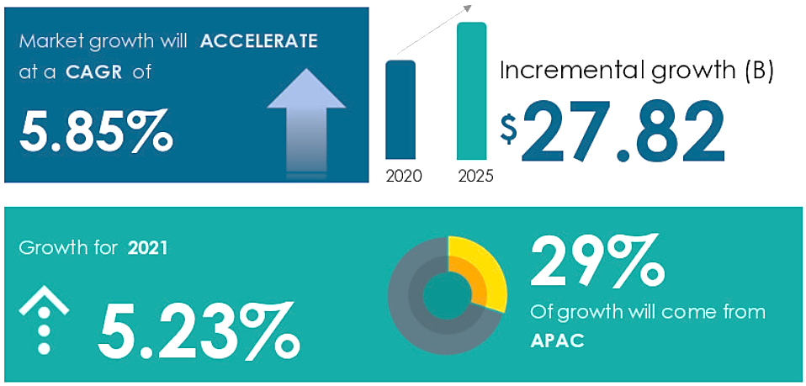

Figure 3 – Latest Funeral Homes and Funeral Services Market forecast and analysis (2021-2025), Source: Technavio

As shown in *Figure 3*, funeral services market analysis highlights a significant trend: 29% of the market's growth originates from the Asia Pacific (APAC) region. This indicates the increasing demand for funeral services in this area, which includes Pakistan, emphasizing the need for innovative and culturally sensitive solutions within the industry.

**Industry:** Funeral Services

* **TAM**

Aligned with the projected growth of the global funeral services market, the TAM is estimated at $39.3 billion by 2031. This encompasses the worldwide demand for various funeral services, including arrangements, ceremonies, burials, cremations, and memorialization.

* **SAM**

Recognizing the cultural significance of funerals in Pakistan and the specific needs of the local population, Sahara's SAM focuses on the segment of the Pakistani population requiring funeral services annually.

* **SOM**

Sahara's initial focus lies in capturing a significant share, around 25%, of the urban and suburban funeral service market in Pakistan.

## Unique Selling Proposition (USP)

Sahara goes beyond simply providing funeral necessities; we offer comprehensive support and compassionate care during a family's time of need. Understanding the cultural and emotional significance of funerals in Pakistan, we provide a centralized, efficient, and culturally sensitive service.

* **24/7 Accessibility:** Our 24-hour helpline and rapid response ensure immediate assistance.
* **Professional Expertise:** Our trained team efficiently manages all funeral arrangements with care and respect.
* **Quality Assurance:** We guarantee high-quality food and catering services for funeral gatherings.
* **Brand Awareness:** Robust advertising ensures Sahara is top-of-mind for families seeking funeral services.

## Cost Leadership or Differentiation

Sahara focuses on differentiation by providing a unique combination of comprehensive services, 24/7 availability, quality assurance, and cultural sensitivity. This approach sets us apart from competitors by offering:

* **Convenience and Accessibility:** Our centralized platform and 24-hour helpline streamline the process for grieving families.
* **Reliability and Trust:** We build trust through consistent professionalism, efficient service, and a commitment to quality.
* **Empathy and Cultural Understanding:** Our services are tailored to respect diverse cultural and religious customs.
* **Strong Brand Presence:** Robust advertising ensures Sahara remains the preferred choice for funeral services.

## Target Market and Customer Personas

Define your target market by answering:

* **Who is Your Product or Service For?**

Families in Pakistan experiencing the loss of a loved one and seeking assistance with funeral arrangements.

* **What Needs Does Your Product or Service Meet?**

We provide efficient and culturally sensitive funeral arrangements, alleviating the logistical and emotional burden on grieving families.

* **Who Is Most Likely to Buy Your Product or Service?**

Families residing in urban and suburban areas value a seamless and respectful funeral service experience.

* **What Demographics are You Targeting?**

Adults between 25 to 65 years old, with middle to upper-middle-income levels, located all across Pakistan.

* **What Psychographics Are You Targeting?**

Individuals who prioritize professionalism, reliability, and efficiency; seek convenience and ease of service; and value cultural and religious traditions related to funeral ceremonies.

### Customer Persona – 1

Meet Ayesha, the busy professional

* **Demographics**
* Age: 40
* Location: Lahore, Pakistan
* Salary: Rs. 135k / month
* **Psychographics**

1. **Goals:** To arrange a respectful and dignified funeral for her loved one without the added stress of managing logistics and details.
2. **Values:** Efficiency, professionalism, reliability, and clear communication.
3. **Pain Points:** Feeling overwhelmed by the complexities of funeral arrangements, concerned about finding a trustworthy and efficient service provider.

* **Behaviors**
* Researches funeral service providers online, comparing prices and services.
* Seeks recommendations from friends and family for reliable funeral services.
* Prioritizes clear communication and timely updates from the service provider.

### Customer Persona – 2

Meet Ali, a traditional elder valuing religious customs

* **Demographics**
* Age: 63
* Location: Karachi, Pakistan
* Salary: Pension-based income
* **Psychographics**

1. **Goals:** To ensure the funeral adheres to his cultural and religious traditions while receiving respectful and dignified service.
2. **Values:** Tradition, community support, respect, dignity, adherence to religious customs.
3. **Pain Points:** Concerned about finding a funeral service provider who understands and respects his specific religious and cultural needs.

* **Behaviors**
* Seeks recommendations from religious leaders and community members for appropriate funeral services.
* Prioritizes services that offer traditional funeral rituals and customs.
* Values a sense of community support and involvement during the funeral process.